# Basic VNF in Openstack

In this section I will describe how to spawn cirros VM on openstack, how to add openwrt image and spawn openwrt VM and simple ping between them.

### Spawn cirros VM

As the cirros image is part of the deployment this should be very easy. Basically we need to do only these 2 steps (we can use Horizon GUI or command line as well). In this section I’m going to use GUI of openstack.

1. Create network with subnet.
   1. To create network go under Project/Network/Networks section.

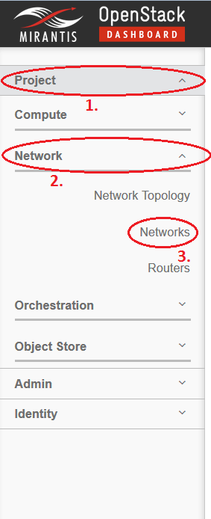

* 1. Click Create Network.
  2. Window with network setup should display. Specify Network Name (eg. Network1) with checked Create Subnet box as seen on picture.



* 1. Next Specify subnet name (eg. Network1-subnet) with Network Address in CIDR format (xxx.xxx.xxx.xxx/xx). This address is pool from which the VMs will have their IP addresses assigned. Click Next.

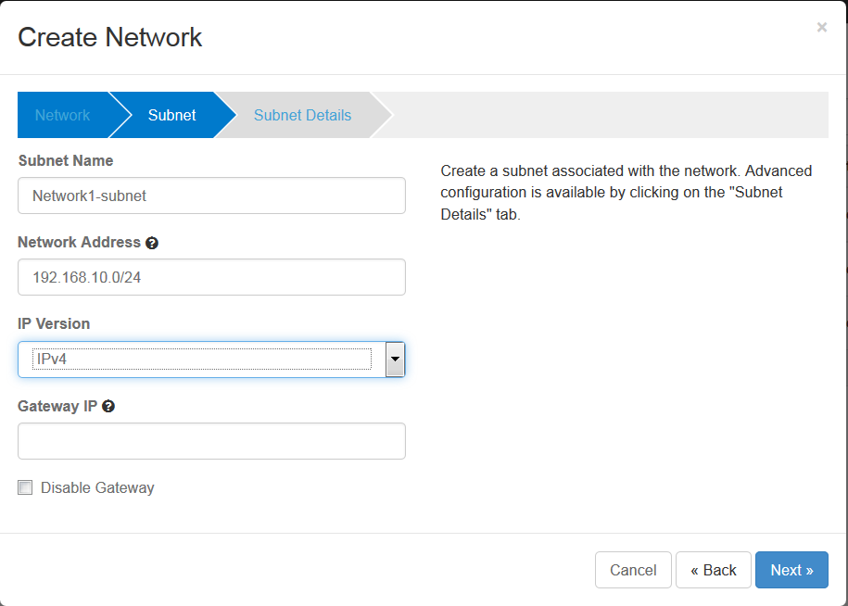

* 1. On the last tab check Enable DHCP and click Create.

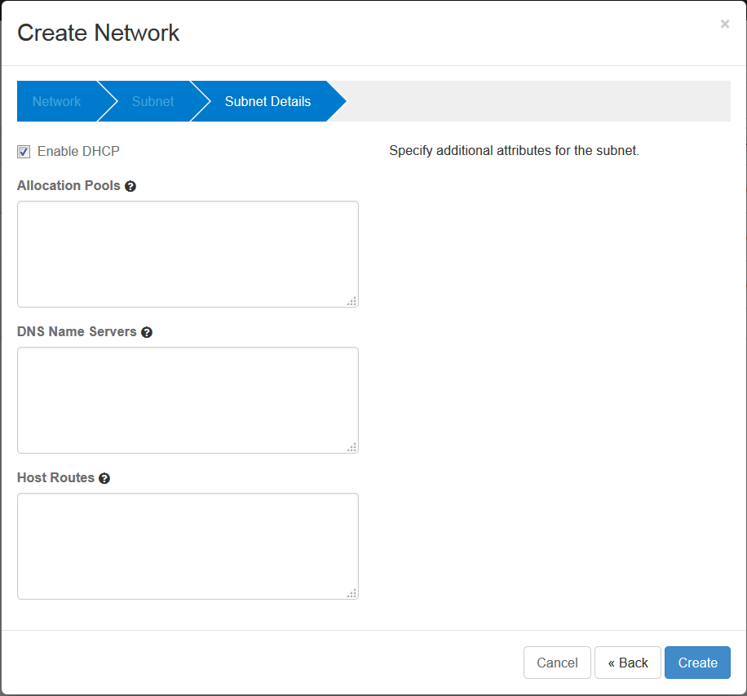

1. Spawn VM from image TestVM with assigned network created in step 1.
   1. To spawn VM go to the Project/Compute/Instances

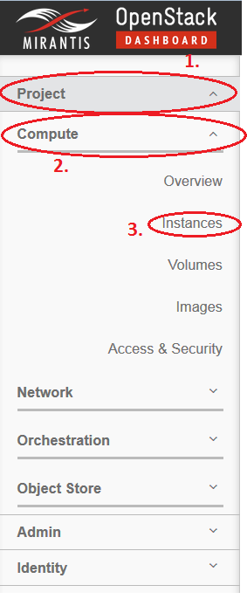

* 1. Click Launch Instance
  2. Launch Instance window should display. Specify Instance Name (eg. vm1), Flavor (eg. m1.micro), Instance Count (eg. 1), Instance Boot Source (eg. Boot from image), and Image name ( eg. TestVM).

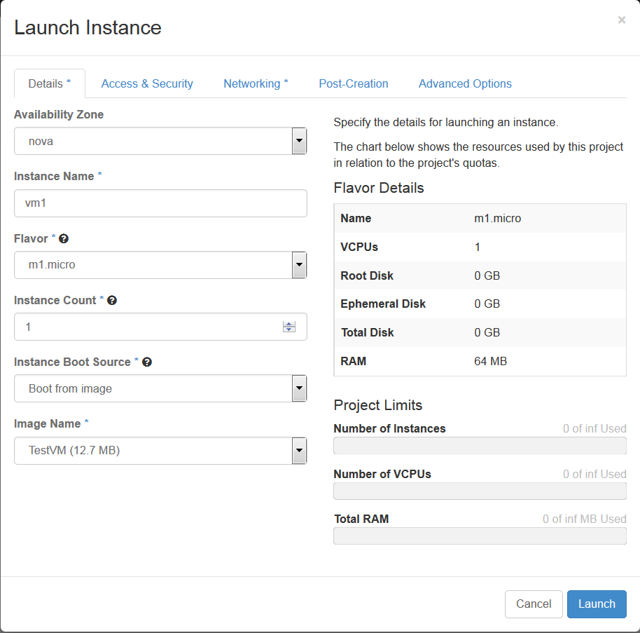

* 1. Go to the Networking tab. By clicking on + sign (or drag & drop) next to our Network1 we will assign the VM to this network.

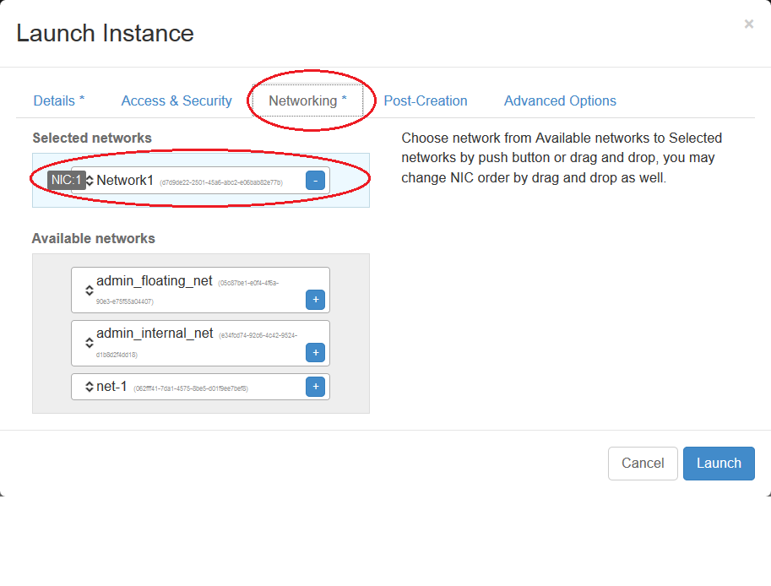

* 1. Now click Launch and we are done. Wait for 3-5 minutes and we should see our VM up and running. If we want to connect to the VM click on the VM name and click Console. We should see VNC console of our running VM.

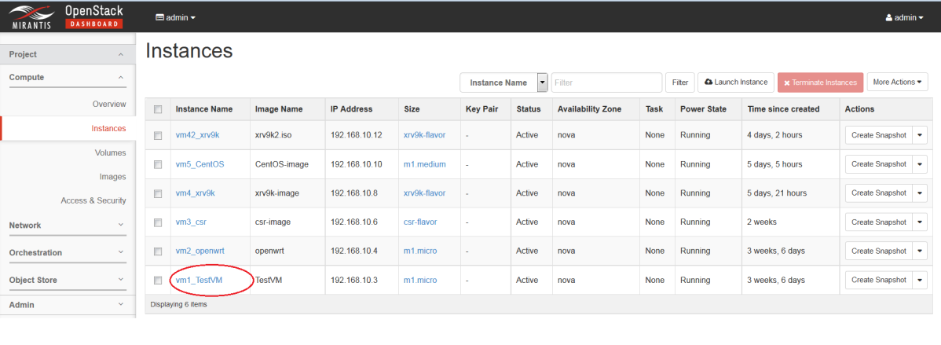

### Spawn openwrt VM

Openwrt image is not part of the deployment. We need to find suitable openwrt image, or build one, and then use glance to create image in openstack.

1. Download openwrt image step 1a) or build one step 1b)
2. Pre-built openwrt image download:

<https://github.com/samos123/openstack-openwrt-image/releases/download/0.1/openwrt-x86-kvm_guest-combined-ext4.img>

1. Or follow this tutorial to build one:

<http://hackstack.org/x/blog/2014/08/17/openwrt-images-for-openstack/>

1. Copy the image to the controller. To access the controller we need to go via fuel and to fuel we can connect from sandbox.

The path is as follows: Local PC -> sandbox PC -> fuel -> controller.

1. I use winscp to copy openwrt image from my local PC to sandbox PC.

NOTE: To save one step we don’t have to download image to local PC and copy to Sandbox VM, we are able to download directly to Sandbox VM using wget. It’s up to user.

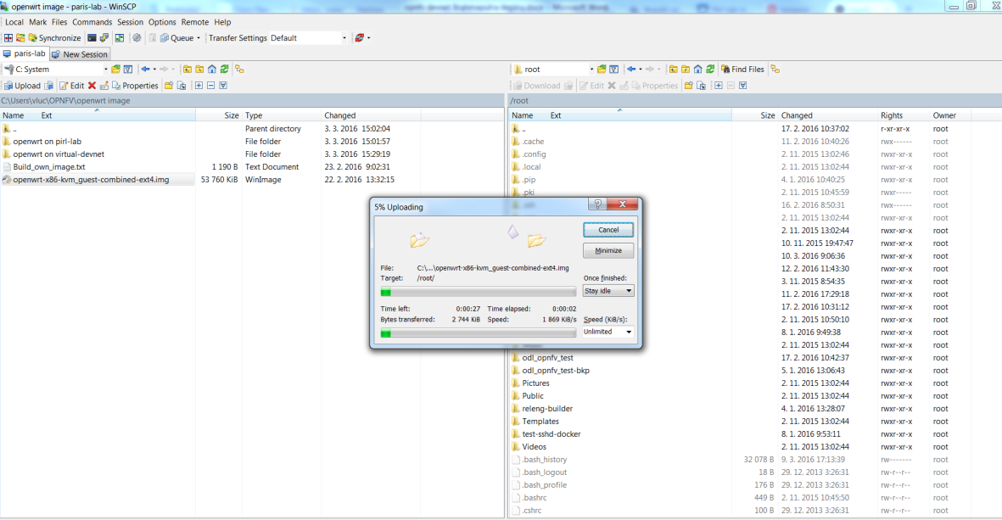

1. Then simply I use scp to copy to fuel:

*# scp openwrt-x86-kvm_guest-combined-ext4.img 10.20.0.2:/root*

1. ssh to fuel

*# ssh* [*root@10.20.0.2*](mailto:root@10.20.0.2) *(root/r00tme)*

1. First find out what is the ip address of controller by running command: fuel node. 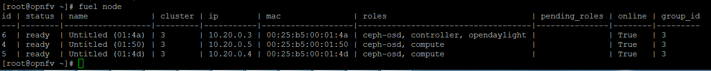

In our case we can see the IP address of controller is 10.20.0.3. Now scp image from fuel VM to controller.

*# scp openwrt-x86-kvm_guest-combined-ext4.img 10.20.0.3:/root*

1. Add openwrt image to the glance. Again we can use the GUI of openstack, but I prefer command line over GUI in image creation.
2. At first we need to connect to controller.

*# ssh* [*root@10.20.0.3*](mailto:root@10.20.0.3) *(no passwd needed)*

1. Next we need to source rc file to get authenticate with openstack.

*# source openrc*

1. Now we can create openwrt image in openstack

*# glance image-create --name "openwrt" --file /root/openwrt-x86-kvm_guest-combined-ext4.img --disk-format qcow2 --container-format bare --protected false --progress*

1. Now the steps aresimilar as for spawning cirros VM
2. We need to create network or we can use one we already created for cirros (If we want to ping from cirros VM to openwrt VM both VMs must be within the same network).
3. Spawn VM from image „openwrt“ with assigned network created in step 1. Steps are very similar to the cirros VM spawn, only when selecting Image name select „openwrt“ instead of „TestVM“.

Now we should be able to connect to cirros VM and openwrt VM via VNC console (use Horizon GUI) and ping from one VM to another.

Running VMs:

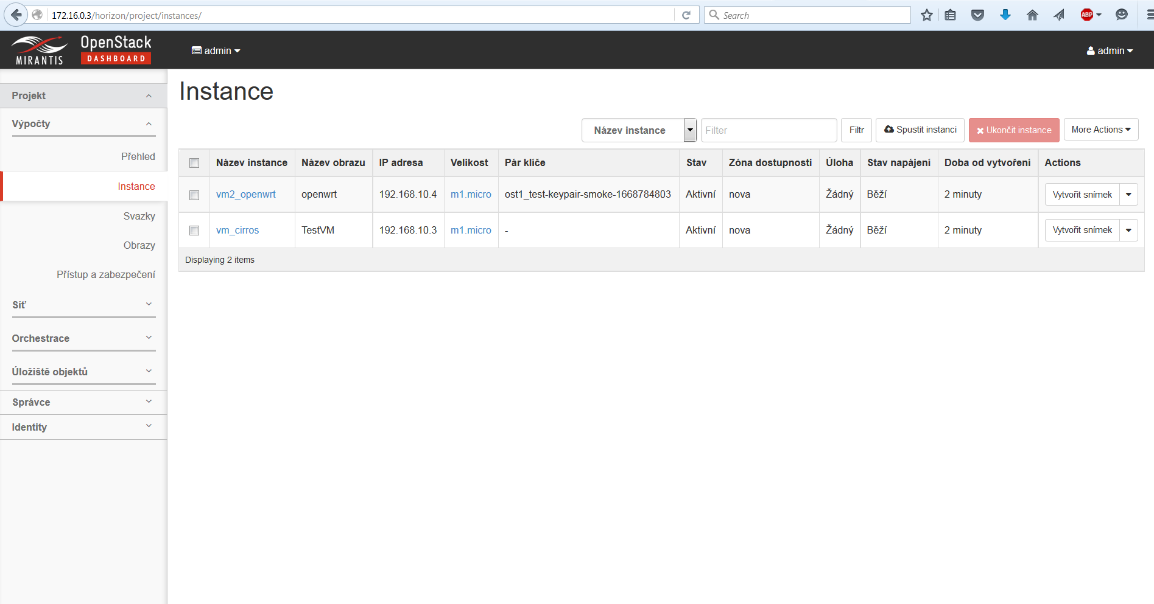

Click on the cirros VM name and then click on Console tab. We should see VNC console. Now ping from cirros VM to openwrt:

